The WITS Geeks
SA Learnerships and Skills Development Portal
Sprint 2 UML Diagrams

Introduction
This document contains the UML diagrams for Sprint 2 of the Youth Opportunities Portal system. It presents different views of the system, including processes, interactions between components, object lifecycles, and system deployment. These diagrams help explain how the system operates and how its components work together.

UML Diagrams Completed (Sprint 2)
- Use Case Diagram
- Activity Diagram (Apply for job opportunity)
- State Machine Diagram (Application)
- Class Diagram
- Deployment Diagram

_________________________________________________________________________________

Scenario view: Use case Diagram
The use case view shows how different users interact with the system. The main user is the applicant, who uses the system to find and apply for opportunities. The administrator and provider are supporting users, where the administrator manages and approves content, and the provider posts opportunities. The system also uses an external service, Google Authentication, for user login and verification.

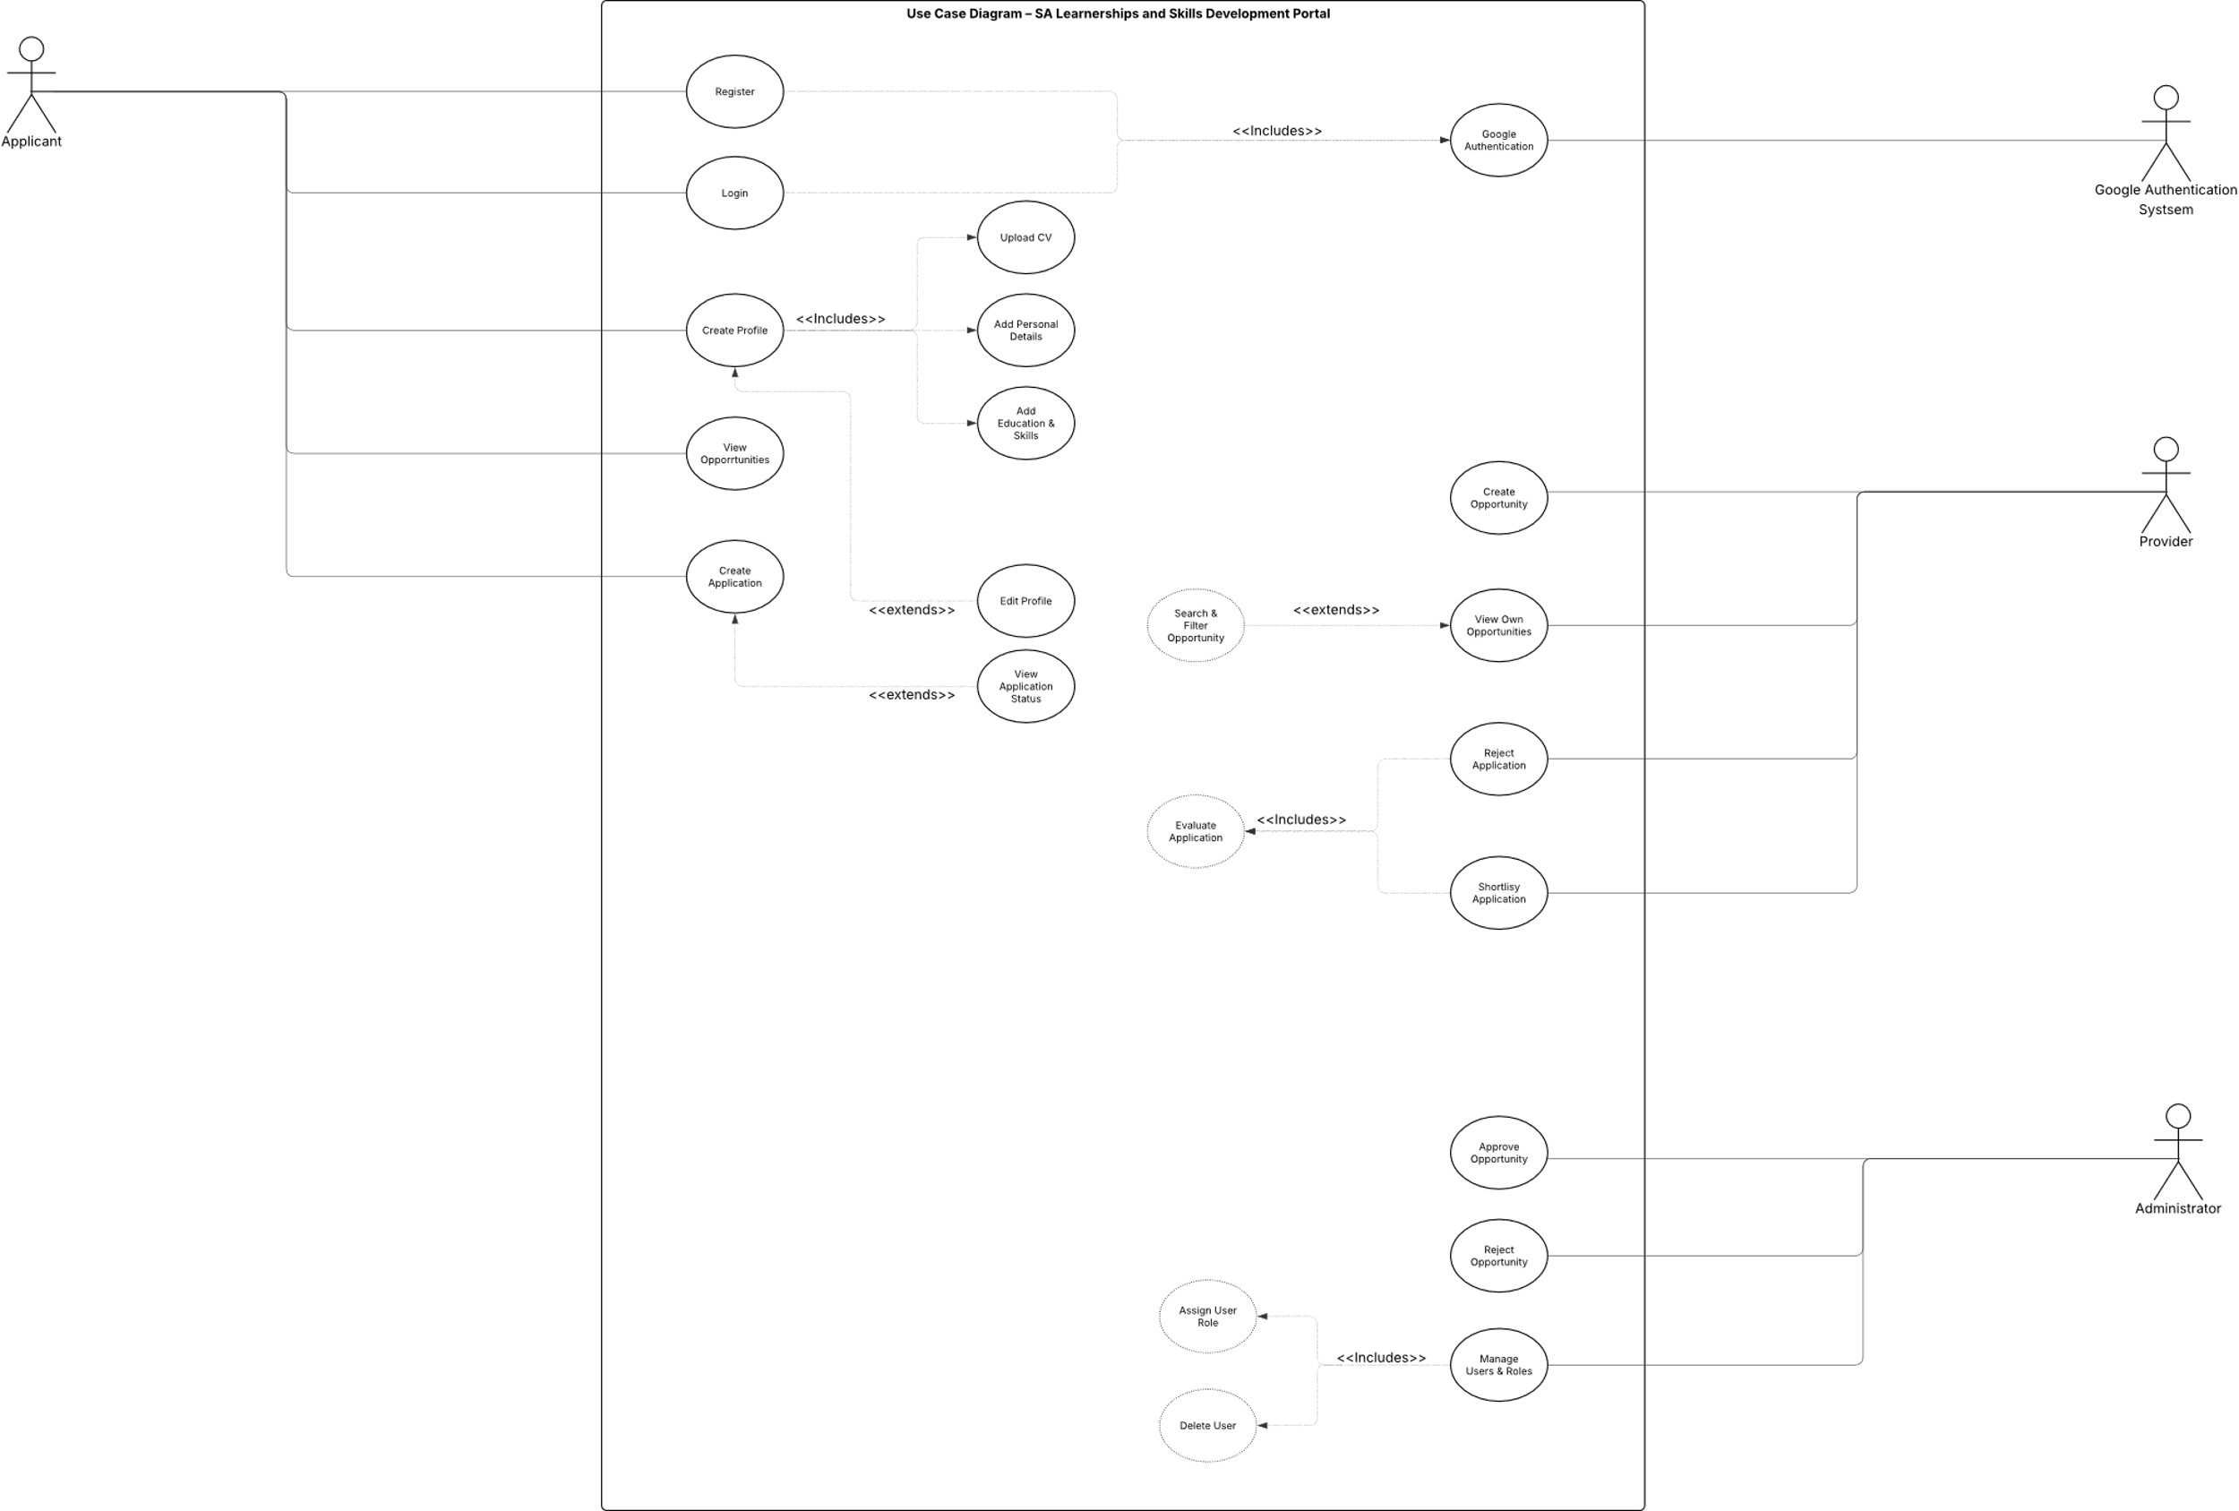
_________________________________________________________________________________

_________________________________________________________________________________

Process View – Activity Diagrams
The activity diagrams represent the process view of the system and show the workflow followed when an applicant applies for an opportunity. The process starts when the applicant submits an application, after which the system validates the information provided. A decision is then made based on this validation to determine whether the application is valid. If valid, the application continues through the review process until a final outcome such as shortlisted, accepted, or rejected is reached. This diagram clearly shows the flow of activities from the start of the process to the final result.
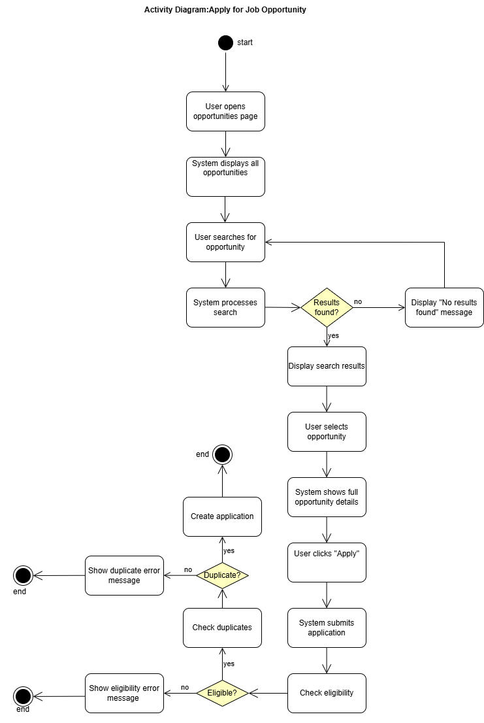

_________________________________________________________________________________

Physical View – Deployment Diagram
The deployment diagram represents the physical view of the system. It shows how the system is deployed in real life and how different parts of it are hosted and connected across platforms.
User Device
This is the device used by the user, such as a laptop or mobile phone. The user accesses the system through a web browser over the internet.
Netlify (Frontend)
This is where the frontend of the system is hosted. It contains the HTML, CSS, and JavaScript files and is responsible for displaying the user interface. Netlify also automatically deploys updates when changes are made.
Azure App Service (Backend)
This is where the backend of the system is deployed. It handles all system logic, processes requests from the frontend, and communicates with the database using REST API endpoints such as /api/users and /api/applications.
MongoDB Atlas (Database)
This is the cloud database used to store all system data, including users, applications, and opportunities. The backend connects to it to store and retrieve information.
Google OAuth (Authentication)
This is an external service used for user authentication. It allows users to securely log in using their Google accounts and verifies their identity.
Summary
Overall, the deployment diagram shows how the system is physically structured across different platforms. The frontend is hosted on Netlify, the backend runs on Azure App Service, the database is stored in MongoDB Atlas, and authentication is handled through Google OAuth.

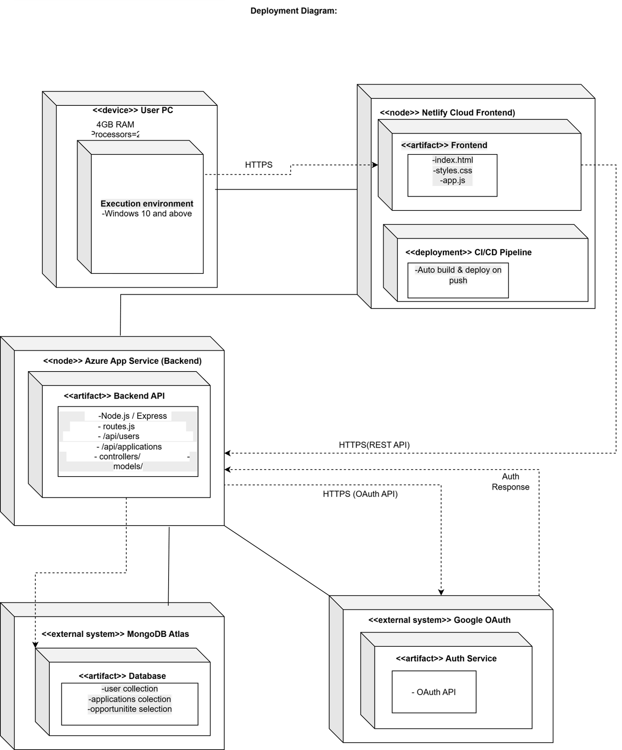

_________________________________________________________________________________

Logical View – State Machine Diagram (Application Object)
The state machine diagram represents the logical view of the system and focuses on the lifecycle of the Application object. It shows how an application changes state as it moves through the system, starting from Draft and moving to Submitted. Once submitted, the system validates the application and moves it into Under Review. From there, the application can go to Shortlisted, Accepted, or Rejected depending on the outcome of the review process. An application can also be withdrawn by the applicant or expire if the deadline is reached. This diagram shows how the application behaves and changes state throughout its lifecycle in the system.
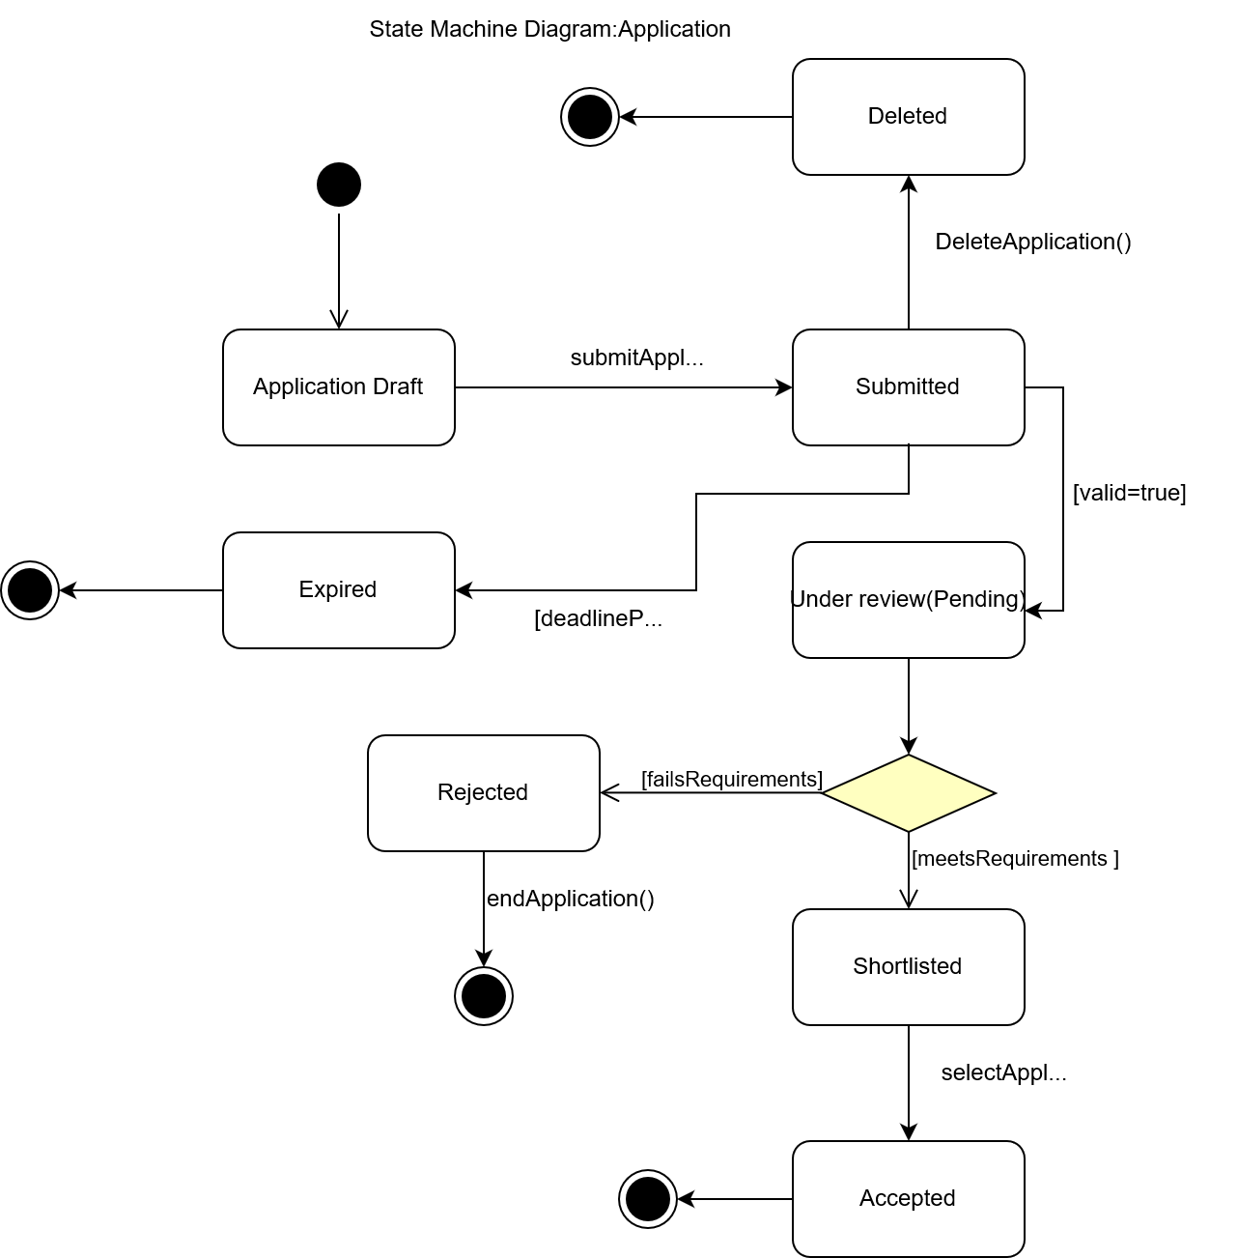
_________________________________________________________________________________

Logical View – Class Diagram (Application as Bridge Entity)
The class diagram represents the logical view of the system and shows how the main classes are structured and related. The key classes include Applicant, Application, Opportunity, and Administrator/Provider.
In this system, the Application class acts as a bridge entity between the Applicant and Opportunity. This is because one applicant can apply for many opportunities, and one opportunity can have many applications. The Application class links these two entities and stores details like application status and submission data, making it the main connecting point in the system.



